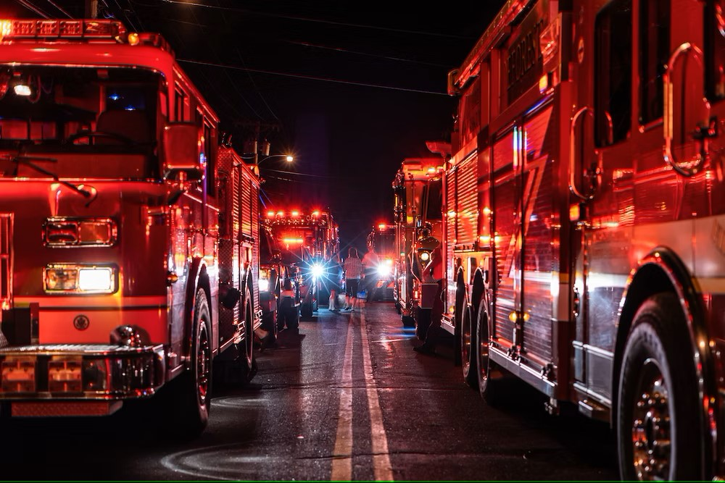

MONTHLY REPORT

2025
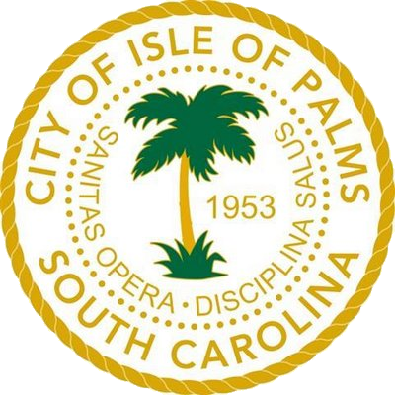

FEBRUARY

ISLE OF PALMS FIRE & RESCUE
Authored by: Craig K. Oliverius, Fire Chief

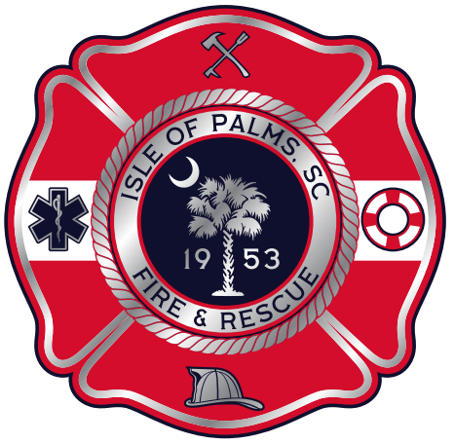

OPERATIONS

Incident by Type
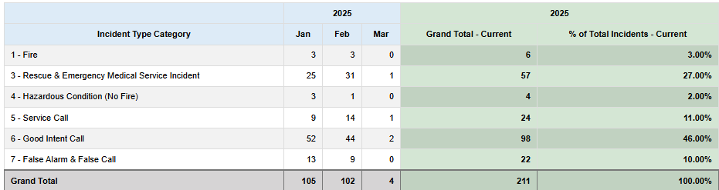

Residency Status
TOTAL INCIDENTS FOR THE MONTH: 102

Resident Calls: 33
Non-Resident Calls: 57
Unknown: 12

Emergency Medical Incidents

Isle of Palms Fire & Rescue
Number of Emergency Medical Incidents: 22

Number of Resident Emergency Medical Incidents: 12
Number of Non-Resident Emergency Medical Incidents: 7
Number of unknown residency Emergency Medical Incidents: 3

Average Unit Performance
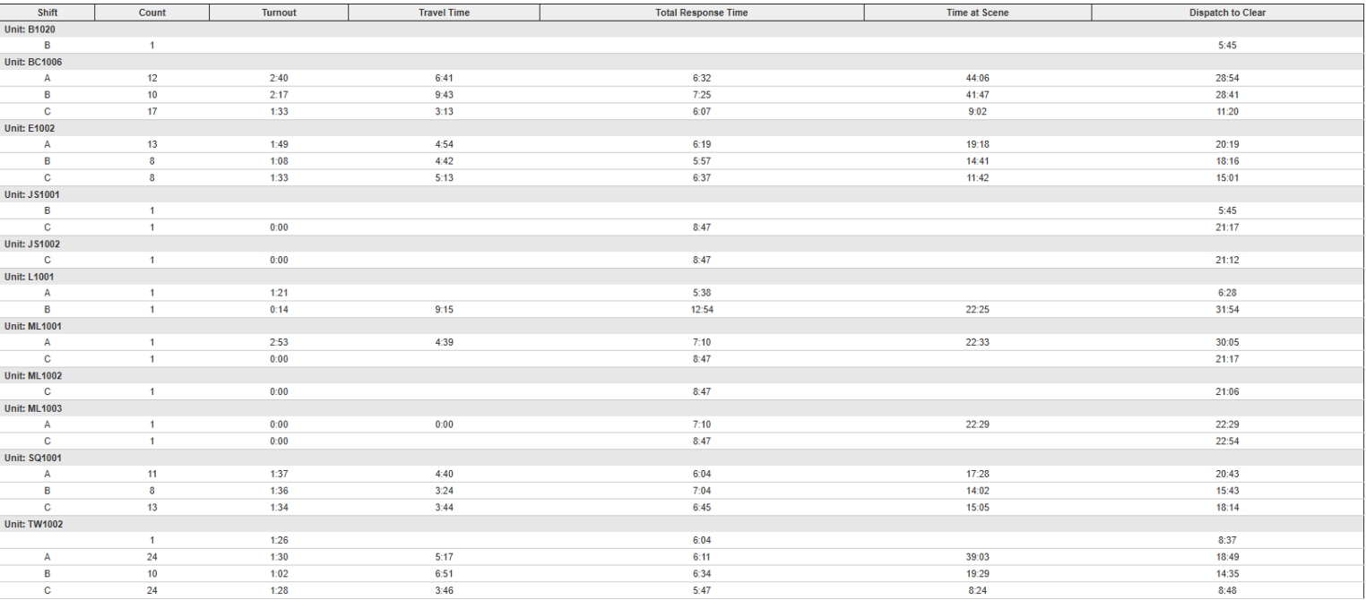

Heat Map

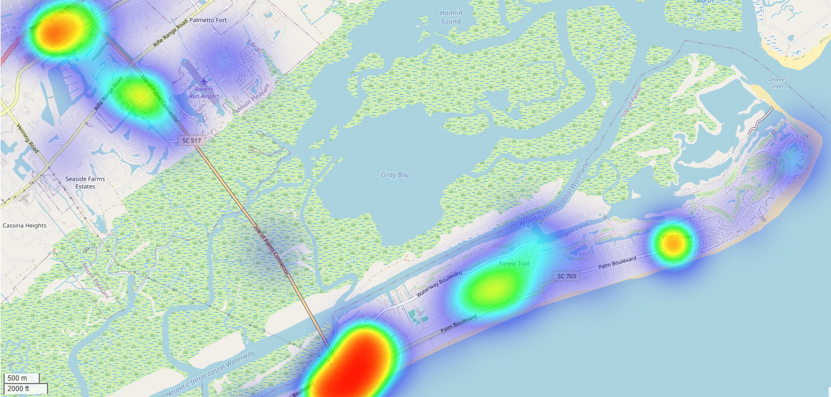

Incidents by Shift and District

Response Mode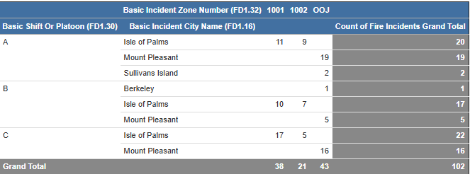

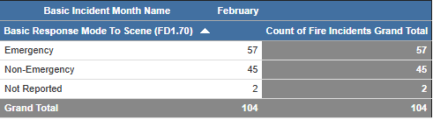

Auto/Mutual Aid
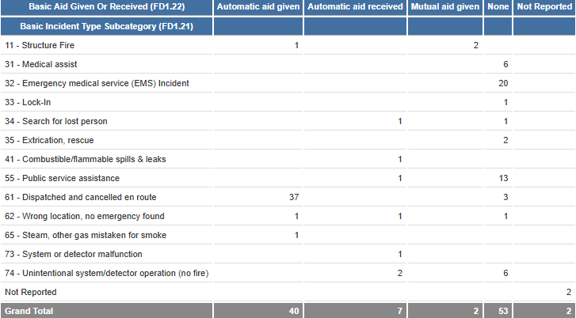

TRAINING DIVISION

Monthly Training Schedule
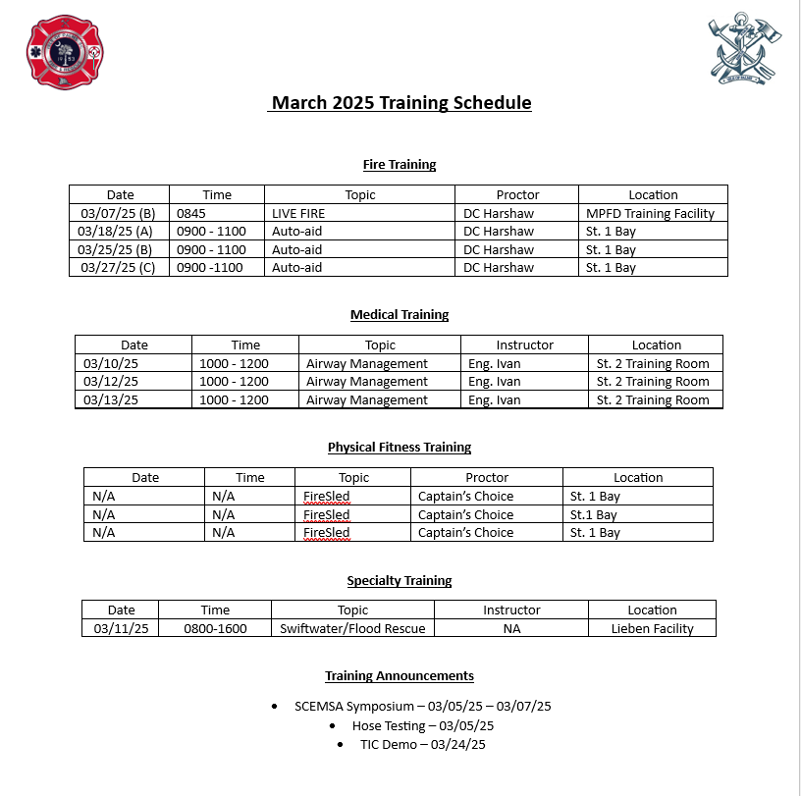

FIRE MARSHAL

Fire Marshal’s Report

February

- Target Hazard Training at Windjammer
- Safety Committee Meeting at City Hall
- Live Fire Training at MPFD Training Facility
- Found Resolution to Coconut Joe's/Smuggler's issue
- LRA Meeting
- Lowcountry Regional Fire Marshal's Meeting at Citadel Mall
- Completed Fire Codes and Standards Training
- Completed Multiple Fire Inspections
- Gave tour of Station 1 to new 911 Dispatchers
- Attended Medical In-service training

